# Programming (general)

## Computer program basics

* A computer program consists of instructions executing one at a time. Basic instruction types are:
  + **Input**: A program gets data, perhaps from a file, keyboard, touchscreen, network, etc.
  + **Process**: A program performs computations on that data, such as adding two values like x + y.
  + **Output**: A program puts that data somewhere, such as to a file, screen, network, etc.
* Programs use **variables** to refer to data
  + The name is due to a variable's value varying as a program assigns a variable like x with new values.

## Computational thinking

* Mathematical thinking became increasingly important throughout the industrial age to enable people to successfully live and work.
  + In the information age, many people believe **computational thinking**, or creating a sequence of instructions to solve a problem, will become increasingly important for work and everyday life.
* A sequence of instructions that solves a problem is called an **algorithm**

# Programming basics

## A first program

* A program starts in **main()**, executing the statements within main's braces { }, one at a time.
* Each statement typically appears alone on a line and ends with a **semicolon**, as English sentences end with a period.
* The **int** **wage** statement creates an integer variable named **wage**. The wage = 20 statement assigns wage with 20.
* The **cout** statements output various values.
* The **return 0** statement ends the program (the 0 tells the operating system the program ended without error).
* **Code** is the textual representation of a program

### Example

| #include <iostream>  using namespace std;  int main() {  int wage;  wage = 20;  cout << "Salary is ";  cout << wage * 40 * 52;  cout << endl;  return 0;  } |
| --- |

## Basic input

* The following statement gets an input value and puts that value into variable x: **cin >>** **x;** cin is short for characters in.

### Example of cin

| #include <iostream>  using namespace std;    int main() {  int wage;    cin >> wage; //the users input to the variable wage    cout << "Salary is ";  cout << wage * 40 * 52;  cout << endl;    return 0;  } |
| --- |

## Basic output: Text

* The **cout** construct supports output; **cout** is short for characters out. Outputting text is achieved via: **cout << "desired text";**. Text in double quotes " " is known as a **string literal**.
  + Multiple cout statements continue printing on the same output line.
* The statement **cout << endl;** starts a new output line, called a **newline**.
  + Note endl is short for "end line". A common error is to type the number "1" or a capital I as in "in", instead of a lower case l as in "end line".

## Outputting a variable's value

* Outputting a variable's value is achieved via: **cout << x;**
* Programmers commonly use a single output statement for each line of output by combining the outputting of text, variable values, and a new line.

### Outputting multiple items with one statement

* + The programmer simply separates the items with **<<** symbols. Such combining can improve program readability because the program's code corresponds more closely to the program's output.

### Example

| #include <iostream>  using namespace std;  int main() {  int wage;  wage = 20;  cout << "Wage is: " << wage << endl;  cout << "Goodbye." << endl;  return 0;  } |
| --- |

* A new output line can also be produced by inserting **\n**, known as a newline character, within a string literal.

# Comments and whitespace

## Comments

* A **comment** is text a programmer adds to code, to be read by humans to better understand the code but ignored by the compiler. Two common kinds of comments exist:
  + A **single-line comment** starts with **//** and includes all the following text on that line. Single-line comments commonly appear after a statement on the same line.
  + A **multi-line comment** starts with **/\*** and ends with **\*/**, where all text between **/* and */** is part of the comment.
    - A multi-line comment is also known as a **block comment**.

## Whitespace

* **Whitespace** refers to blank spaces (space and tab characters) between items within a statement and blank lines between statements (called newlines).
  + A compiler ignores most whitespace.

### Example of good Whitespace

| #include <iostream>  using namespace std;  int main() {  int myFirstVar; // Aligned comments yield less  int yetAnotherVar; // visual clutter  int thirdVar;    // Above blank line separates variable declarations from the rest  cout << "Enter a number: ";  cin >> myFirstVar;    // Above blank line separates user input statements from the rest  yetAnotherVar = myFirstVar; // Aligned = operators  thirdVar = yetAnotherVar + 1;  // Also notice the single-space on left and right of + and =  // (except when aligning the second = with the first =)  cout << "Final value is " << thirdVar << endl; // Single-space on each side of <<    return 0; // The above blank line separates the return from the rest  } |
| --- |

# Errors and Warnings

## Syntax Errors

* **Syntax error** - is to violate a programming language's rules on how symbols can be combined to create a program.

### Example

| main.cpp:6:27: error: expected ';' after expression  cout << "Traffic today"  ^  ; |
| --- |

## Unclear error messages

* Sometimes errors can be wrong, like it might say there is a missing “;” but really there's a missing “<<” just as an example. Look through the code to verify. Look at the code before it says where the error was.
  + Focus on the FIRST error message, ignoring the rest.
  + Look at the reported line of the first error message. If an error is found, fix it. Else, look at the previous few lines.
  + Compile, repeat.

## Logic errors

* A syntax error is known as a type of **compile-time error.**
* A **logic error**, also called a **bug**, is an error that occurs while a program runs.
  + The program would compile but would not run as intended.
    - Writing many lines of code without compiling and running is bad practice.
    - New programmers should compile and run programs after every few lines. Even experienced programmers compile and run frequently.

## Compiler warnings

* A compiler will sometimes report a **warning**, which doesn't stop the compiler from creating an executable program but indicates a possible logic error.

# Computers and programs (general)

## Switches

* A **switch** controls whether or not electricity flows through a wire.
  + In an electronically controlled switch, a positive voltage at the control input allows electricity to flow, while a zero voltage prevents the flow.
  + Engineers soon realized they could use electronically controlled switches to perform simple calculations.
  + The engineers treated a positive voltage as a "1" and a zero voltage as a "0".
    - 0s and 1s are known as **bits (binary digits)**.
  + They built connections of switches, known as **circuits**, to perform calculations such as multiplying two numbers.

## Processors and memory

* To support different calculations, circuits called **processors** were created to process (aka execute) a list of desired calculations, with each calculation called an **instruction**.
* A **memory** is a circuit that can store 0s and 1s in each of a series of thousands of addressed locations, like a series of addressed mailboxes that each can store an envelope (the 0s and 1s).

## Instructions

* Below are some sample types of instructions that a processor might be able to execute, where X, Y, Z, and num are each an integer.

### Example

| **Add X, #num, Y** | Adds data in memory location X to the number num, storing the result in location Y. |
| --- | --- |
| **Sub X, #num, Y** | Subtracts num from data in location X, storing the result in location Y. |
| **Mul X, #num, Y** | Multiplies data in location X by num, storing result in location Y. |
| **Div X, #num, Y** | Divides data in location X by num, storing the result in location Y. |
| **Jmp Z** | Tells the processor that the next instruction to execute is in memory location Z. |

* Memory stores instructions and data as 0s and 1s.
* The material will commonly draw the memory with the corresponding instructions and data to improve readability.
* The programmer-created sequence of instructions is called a **program**, **application**, or just **app**.

## Writing Computer Programs

* Instructions represented as 0s and 1s are known as machine instructions, and a sequence of **machine instructions,** together form an **executable program** (sometimes just called an **executable**).
* **Assemblers** to automatically translate human readable instructions, such as "Mul 97, #9, 98", known as **assembly** language instructions, into machine instructions.
  + The assembler program thus helped programmers write more complex programs.
* To support high-level languages, programmers **created compilers**, which are programs that automatically translate high-level language programs into executable programs.

# Variables and assignments (general)

## Variables and assignments

* In a program, a **variable** is a named item, such as x or numPeople, used to hold a value.
* An **assignment** assigns a variable with a value
  + In programming, = is an assignment of a left-side variable with a right-side value. = is NOT equality as in mathematics.
* Increasing a variable's value by 1, as in x = x + 1, is common, and known as **incrementing** the variable.

# Variables (int)

## Variable declarations

* A **variable declaration** is a statement that declares a new variable, specifying the variable's name and type.
  + int userAge;

## Assignment statement

* An **assignment statement** assigns the variable on the left-side of the = with the current value of the right-side expression.
* An **expression** may be a number like 80, a variable name like numApples, or a simple calculation like numApples + 1. Simple calculations can involve standard math operators like +, -, and *, and parentheses as in 2 * (numApples - 1).
  + An integer like 80 appearing in an expression is known as an **integer literal**.
  + Although not required, an integer variable is often assigned an initial value when declared.

# Identifiers

## Rules for identifiers

* A name created by a programmer for an item like a variable or function is called an **identifier**. An identifier must:
  + be a sequence of letters (a-z, A-Z), underscores (_), and digits (0-9)
  + start with a letter or underscore
* Identifiers are **case sensitive**, meaning upper and lower case letters differ.
* A **reserved word** is a word that is part of the language, like int, short, or double. A reserved word is also known as a **keyword**.
  + A programmer cannot use a reserved word as an identifier. Many language editors will automatically color a program's reserved words.

| alignas (since C++11)  alignof (since C++11)  and  and_eq  asm  auto  bitand  bitor  bool  break  case  catch  char  char16_t (since C++11)  char32_t (since C++11)  class  compl  const  constexpr (since C++11)  const_cast  continue | decltype (since C++11)  default  delete  do  double  dynamic_cast  else  enum  explicit  export  extern  false  float  for  friend  goto  if  inline  int  long  mutable | namespace  new  noexcept (since C++11)  not  not_eq  nullptr (since C++11)  operator  or  or_eq  private  protected  public  register  reinterpret_cast  return  short  signed  sizeof  static  static_assert (since C++11)  static_cast | struct  switch  template  this  thread_local (since C++11)  throw  true  try  typedef  typeid  typename  union  unsigned  using  virtual  void  volatile  wchar_t  while  xor  xor_eq |
| --- | --- | --- | --- |

## Style guidelines for identifiers

* While various (crazy-looking) identifiers may be valid, programmers may follow identifier naming conventions (style) defined by their company, team, teacher, etc. Two common conventions for naming variables are:
  + Camel case: **Lower camel case** abuts multiple words, capitalizing each word except the first, as in numApples or peopleOnBus.
  + Underscore separated: Words are lowercase and separated by an underscore, as in num_apples or people_on_bus.

# Arithmetic Expressions (general)

## Basics

* An **expression** is any individual item or combination of items, like variables, literals, operators, and parentheses, that evaluates to a value
* A **literal** is a specific value in code
* An **operator** is a symbol that performs a built-in calculation

| Arithmetic operator | Description |
| --- | --- |
| + | The **addition** operator is **+**, as in x + y. |
| - | The **subtraction** operator is **-**, as in x - y. Also, the - operator is for **negation**, as in -x + y, or x + -y. |
| * | The **multiplication** operator is **\***, as in x * y. |
| / | The **division** operator is **/**, as in x / y. |

## Evaluation of expressions

* An expression **evaluates** to a value, which replaces the expression.
* An expression is evaluated using the order of standard mathematics, such order known in programming as **precedence rules**

| Operator/Convention | Description | Explanation |
| --- | --- | --- |
| **( )** | Items within parentheses are evaluated first | In 2 * (x + 1), the x + 1 is evaluated first, with the result then multiplied by 2. |
| **unary -** | - used for negation (unary minus) is next | In 2 * -x, the -x is computed first, with the result then multiplied by 2. |
| **\* / %** | Next to be evaluated are *, /, and %, having equal precedence. | (% is discussed elsewhere) |
| **+ -** | Finally come + and - with equal precedence. | In y = 3 + 2 * x, the 2 * x is evaluated first, with the result then added to 3, because * has higher precedence than +. Spacing doesn't matter: y = 3+2 * x would still evaluate 2 * x first. |
| **left-to-right** | If more than one operator of equal precedence could be evaluated, evaluation occurs left to right. | In y = x * 2 / 3, the x * 2 is first evaluated, with the result then divided by 3. |

# Arithmetic expressions (int)

## Compound operators

* Special operators called **compound operators** provide a shorthand way to update a variable, such as userAge **+=** 1 being shorthand for userAge = userAge + 1. Other compound operators include **-=**, **\*=**, **/=**, and **%=**

# Floating-point numbers (double)

## FLoating-point (double) variables

* A **floating-point number** is a real number containing a decimal point that can appear anywhere (or "float") in the number.
* A **double** variable stores a floating-point number. Ex: double milesTravel; declares a double variable.
* A **floating-point literal** is a number with a fractional part, even if the fraction is 0, as in 1.0, 0.0, or 99.573
  + Good practice is to always have a digit before the decimal point, as in 0.5, since .5 might mistakenly be viewed as 5.

## Choosing a variable type (double vs. int)

* A programmer should choose a variable's type based on the type of value held.
  + Integer variables are typically used for values that are counted, like 42 cars, 10 pizzas, or -95 days.
  + Floating-point variables are typically used for measurements, like 98.6 degrees, 0.00001 meters, or -55.667 degrees.
  + Floating-point variables are also used when dealing with fractions of countable items, such as the average number of cars per household.

## Floating-point division by zero

* If the dividend and divisor in floating-point division are both 0, the division results in a "not a number". **Not a number** (**NaN**) indicates an unrepresentable or undefined value. Printing a floating-point variable that is not a number outputs nan.

# Constant variables

* An initialized variable whose value cannot change is called a **constant variable**

### Example

| #include <iostream>  using namespace std;  /*  * Estimates distance of lightning based on seconds  * between lightning and thunder  */  int main() {  const double SPEED_OF_SOUND = 761.207; // Miles/hour (sea level)  const double SECONDS_PER_HOUR = 3600.0; // Secs/hour  double secondsBetween;  double timeInHours;  double distInMiles;    cout << "Enter seconds between lightning and thunder: ";  cin >> secondsBetween;    timeInHours = secondsBetween / SECONDS_PER_HOUR;  distInMiles = SPEED_OF_SOUND * timeInHours;    cout << "Lightning strike was approximately" << endl;  cout << distInMiles << " miles away." << endl;    return 0;  } |
| --- |

# Using math functions

## Basics

* A standard **math library** has about 20 math operations, known as functions. A programmer can include the library and then use those math functions.
  + #include <cmath>
* A **function** is a list of statements executed by invoking the function's name, such invoking is known as a **function call**. Any function input values, or **arguments**, appear within ( ), separated by commas if more than one.

| Function | Behavior | Example |
| --- | --- | --- |
| sqrt(x) | Square root of x | sqrt(9.0) evaluates to 3.0. |
| pow(x, y) | Power: xy | pow(6.0, 2.0) evaluates to 36.0. |
| fabs(x) | Absolute value of x | fabs(-99.5) evaluates to 99.5. |

* The "c" in cmath indicates that the library comes from a C language library.
* Some math functions for integers are in a library named cstdlib, requiring: #include <cstdlib>. Ex: abs() computes the absolute value of an integer.

# Integer division and modulo

## Division: Integer rounding

* When the operands of / are integers, the operator performs integer division, which does not generate any fraction.
* If one of the numbers you are dividing is a floating point double it will return a double

## Division: Divide by 0

* For integer division, the second operand of / or % must never be 0, because division by 0 is mathematically undefined.
* A **divide-by-zero error** occurs at runtime if a divisor is 0, causing a program to terminate.
  + A divide-by-zero error is an example of a **runtime error**, a severe error that occurs at runtime and causes a program to terminate early.

## Modulo %

* The **modulo operator** (**%**) evaluates the remainder of the division of two integer operands. Ex: 23 % 10 is 3.
  + Examples:
    - 24 % 10 is 4. Reason: 24 / 10 is 2 with remainder 4.
    - 50 % 50 is 0. Reason: 50 / 50 is 1 with remainder 0.
    - 1 % 2 is 1. Reason: 1 / 2 is 0 with remainder 1.
    - 10 % 4.0 is not valid. "Remainder" only makes sense for integer operands.
* Both operands of % must be integers.

# Type Conversions

* A **type conversion** is a conversion of one data type to another, such as an int to a double.
* The compiler automatically performs several common conversions between int and double types, such automatic conversions are known as **implicit conversion**.

## Type casting

* A **type cast** explicitly converts a value of one type to another type.
* The **static_cast** operator (static_cast<type>(expression)) converts the expression's value to the indicated type.
  + Ex: If myIntVar is 7, then static_cast<double>(myIntVar) converts int 7 to double 7.0.
* A common error is to accidentally perform integer division when floating-point division was intended.
* Another common error is to cast the entire result of integer division, rather than the operands, thus not obtaining the desired floating-point division.

# Binary

* Because each memory location is composed of bits (0s and 1s), a processor stores a number using base 2, known as a **binary number**.
* For a number in the more familiar base 10, known as a **decimal number**, each digit must be 0-9 and each digit's place is weighed by increasing powers of 10.

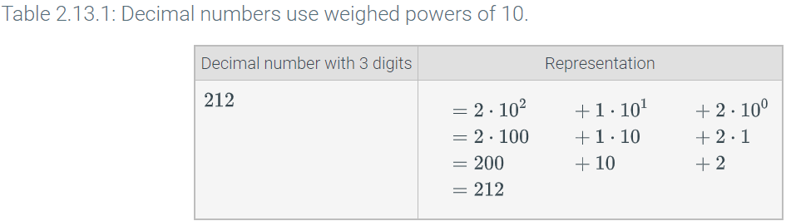

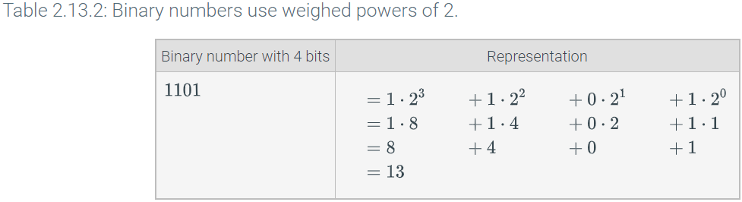

# Characters

## Basics

* A variable of **char** type, as in char myChar;, can store a single character like the letter m. A **character literal** is surrounded with single quotes, as in myChar = 'm';
* cin can be used to get one character from input. Ex: cin >> myChar;

## A character is initially stored as a number

* Under the hood, a char variable stores a number. Ex: 'a' is stored as 97. In an output statement, the compiler outputs the number's corresponding character.
* When outputting a char variable, the compiler converts the number to the appropriate letter.

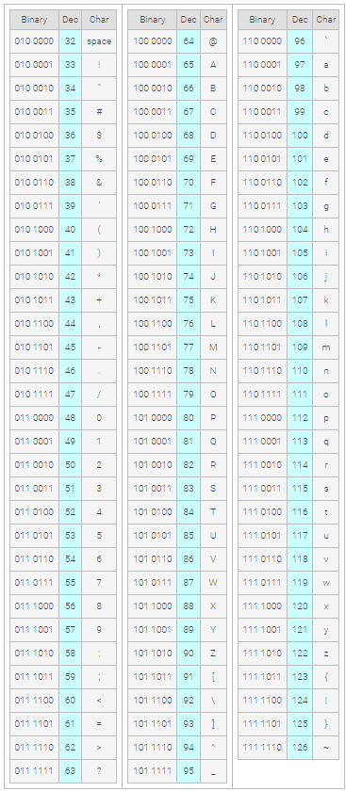

* 7 without quotes is an integer literal, so is stored as 7. In contrast, '7' with quotes is a character literal, and would be stored as 55 (per the ASCII table).

## Escape sequences

* In addition to regular characters like Z, $, or 5, character encoding includes numbers for several special characters. Ex: A newline character is encoded as 10. Because no visible character exists for a newline, the language uses an **escape sequence**: A two-character sequence starting with \ that represents a special character.

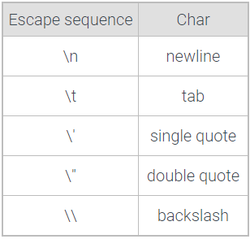

* A common error is to use double quotes rather than single quotes around a character literal, as in myChar = "x", yielding a compiler error.
* Similarly, a common error is to forget the quotes around a character literal, as in myChar = x, usually yielding a compiler error (unless x is also a declared variable, then perhaps yielding a logic error).

# Strings

## Strings and string literals

* A ***string*** is a sequence of characters.
* A ***string literal*** surrounds a character sequence with double quotes, as in "Hello", "52 Main St.", or "42", vs. an integer literal like 42 or character literal like 'a'. Various characters may be in a string, such as letters, numbers, spaces, or symbols like $ or %, as in "$100 for Julia!!"

## String variables and assignments

* Some variables should hold a string. A string data type isn't built into C++ like char, int, or double, but is available in the standard library and can be used after adding: #include <string>.

## Getting a string without whitespaces from input

* A ***whitespace character*** is a character used to represent horizontal and vertical spaces in text, and includes spaces, tabs, and newline characters.
  + Ex: "Oh my goodness!" has two whitespace characters, one between h and m, the other between y and g.
* The approach automatically skips initial whitespace, then gets characters until the next whitespace is seen.
  + cin << userString;
  + If the user tries to input “Hi there”, userString will only save “Hi”
  + If the user tries to input “ Very fun.”, userString will only save “Very”

## Getting a string with whitespace from input

* The function ***getline***(cin, stringVar) gets all remaining text on the current input line, up to the next newline character (which is removed from input but not put in stringVar).
  + getline(cin, firstString);
* Mixing cin >> and getline() can be tricky, because cin >> leaves the newline in the input, while getline() does not skip leading whitespace.

# Integer overflow

* An integer variable cannot store a number larger than the maximum supported by the variable's data type. An ***overflow*** occurs when the value being assigned to a variable is greater than the maximum value the variable can store.
  + Int can store up to 32 bits
  + Double can store up to 64 bits
* Most compilers detect when a statement assigns to a variable a literal constant so large as to cause overflow.
  + The compiler may not report a syntax error (the syntax is correct), but may output a ***compiler warning*** message that indicates a potential problem.
  + A GNU compiler outputs the message "warning: overflow in implicit constant conversion", and a Microsoft compiler outputs "warning: '=': truncation of constant value".
    - *Generally, good practice is for a programmer to not ignore compiler warnings.*

# Numeric data types

| Declaration | Size | Supported number range | Standard-defined minimum size |
| --- | --- | --- | --- |
| char myVar; | 8 bits | -128 to 127 | 8 bits |
| short myVar; | 16 bits | -32,768 to 32,767 | 16 bits |
| long myVar; | 32 bits | -2,147,483,648 to 2,147,483,647 | 32 bits |
| long long myVar; | 64 bits | -9,223,372,036,854,775,808 to 9,223,372,036,854,775,807 | 64 bits |
| int myVar; | 32 bits | -2,147,483,648 to 2,147,483,647 | *16 bits* |

| Declaration | Size | Supported number range |
| --- | --- | --- |
| float x; | 32 bits | -3.4x1038 to 3.4x1038 |
| double x; | 64 bits | -1.7x10308 to 1.7x10308 |

# Unsigned

| Declaration | Size | Supported number range | Standard-defined minimum size |
| --- | --- | --- | --- |
| unsigned char myVar; | 8 bits | 0 to 255 | 8 bits |
| unsigned short myVar; | 16 bits | 0 to 65,535 | 16 bits |
| unsigned long myVar; | 32 bits | 0 to 4,294,967,295 | 32 bits |
| unsigned long long myVar; | 64 bits | 0 to 18,446,744,073,709,551,615 | 64 bits |
| unsigned int myVar; | 32 bits | 0 to 4,294,967,295 | *16 bits* |

# Random numbers

## Generating a random number

* The ***rand()*** function, in the C standard library, returns a random integer each time the function is called, in the range 0 to RAND_MAX.
* Usually, a programmer wants a random integer restricted to a specific number of possible values. The modulo operator % can be used. Ex: integer % 10 has 10 possible remainders: 0, 1, 2, ..., 8, 9.
  + rand() % 3 will give you either 0, 1, 2
  + rand() % 10 will give you either 0, 1, 2, 3, 4, 5, 6, 7, 8, 9

## Specific ranges

* Example:
  + A programmer wants random integers in the range 10 to 15. The number of possible values is 15 − 10 + 1. (People often forget the + 1.)
  + rand() % 6 generates 6 possible values as desired, but with range 0 to 5.
  + Adding 10 still generates 6 values, but now those values start at 10. The range thus becomes 10 to 15.

## Pseudo-random

* The integers generated by rand() are known as pseudo-random. "Pseudo" means "not actually, but having the appearance of". The integers are pseudo-random because each time a program runs, calls to rand() yield the same sequence of values. Earlier in this section, a program called rand() three times and output 16807, 282475249, 1622650073. Every time the program is run, those same three integers will be printed. Such reproducibility is important for testing some programs.
* Internally, the rand() function has an equation to compute the next "random" integer from the previous one, (invisibly) keeping track of the previous one. For the first call to rand(), no previous random integer exists, so the function uses a built-in integer known as the ***seed***. By default, the seed is 1. A programmer can change the seed using the function srand(), as in srand(2) or srand(99).
* If the seed is different for each program run, the program will get a unique sequence. One way to get a different seed for each program run is to use the current time as the seed. The function ***time()*** returns the number of seconds since Jan 1, 1970.
  + Note that the seeding should only be done once in a program, before the first call to rand().
  + By starting a program with srand(time(0)), calls to rand() will yield a different integer sequence for each successive program run.

# Debugging

* ***Debugging*** is the process of determining and fixing the cause of a problem in a computer program.
  + ***Troubleshooting*** is another word for debugging.
    - Predict a possible cause of the problem
    - Conduct a test to validate the problem
    - Repeat
  + A common error among new programmers is to try to debug without a methodical process, instead staring at the program, or making random changes to see if the output is improved.
    - Manually set a variable to a value.
    - Insert print statements to observe variable values.
    - Comment out unused code.
    - Visually inspect the code (not every test requires modifying/running the code).

# Auto (since C++11)

* In a variable declaration, using ***auto*** as the type specifier causes the compiler to automatically deduce the type from the initializer.